**Name: Atharva Velhankar  
Class: SE (A)  
Roll No: 22508  
Subject: IOTL**

**Lab Practical 6**

Problem Statement:

Create a program that illuminates the green LED if the counter is less than 100, illuminate the yellow LED if the counter is between 101 and 200 and illuminates the red LED if the counter is greater than 200.

//Code:

import time

from gpiozero import LED

led1 = LED(7)

led2 = LED(22)

led3 = LED(23)

number=0

while True:

time.sleep(0.2)

if number<=100:

led1.off()

led2.on()

led3.on()

elif number>201 and number<=300:

led1.on()

led2.off()

led3.on()

elif number>101 and number<=200:

led1.on()

led2.on()

led3.off()

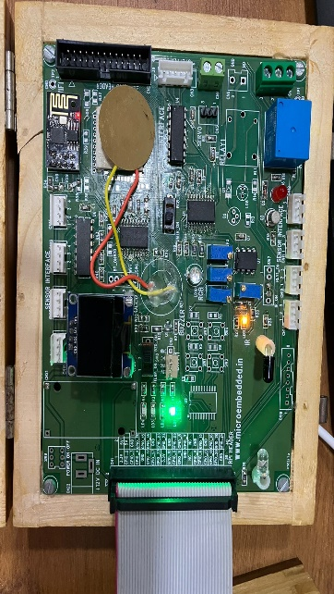 number=number+1

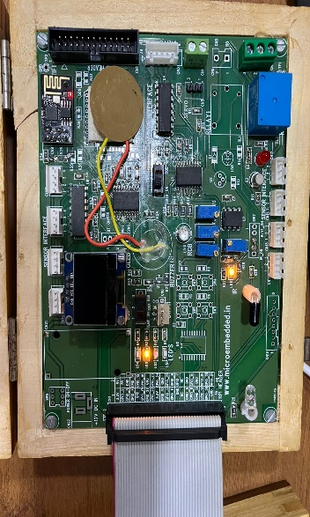

OUTPUT:

When counter value is less than 100. When counter value is more than 200

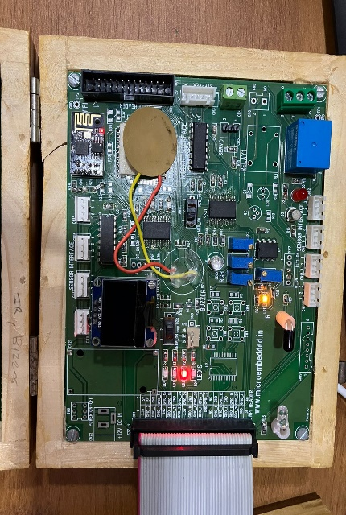  
  
  
  
When counter value is between 100 and 200

**Name: Atharva Velhankar  
Class: SE (A)  
Roll No: 22508  
Subject: IOTL**

**Lab Practical 7**

Problem Statement:

Create a program so that when the user enters ‘b’ the green light blinks, ‘g’ the green light is illuminated ‘y’ the yellow light is illuminated and ‘r’ the red light is illuminated.

//Code:

import time

from gpiozero import LED

led1 = LED(7)

led2 = LED(22)

led3 = LED(23)

led4 = LED(25)

led1.on()

led2.on()

led3.on()

led4.on()  
  
key=input("Enter Character")

print(key)

while True:

time.sleep(0.2)

key=input("Enter Character")

print (key)

if key=='g' or key=='G':

led1.off()

led2.on()

led3.on()

led4.on()

elif key=='r' or key=='R':

led1.on()

led2.off()

led3.on()

led4.on()

elif key=='y' or key=='Y':

led1.on()

led2.on()

led3.off()

led4.on()

else :

led1.on()

led2.on()

led3.on()

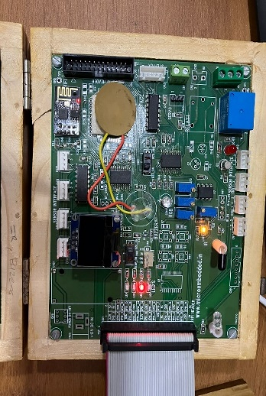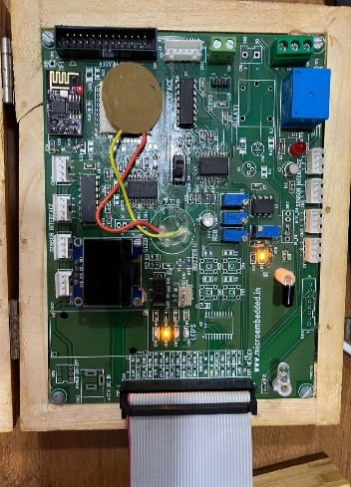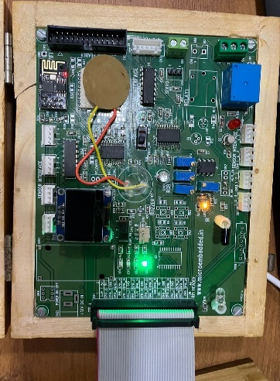 led4.on()  
OUTPUT:  
when user enters the ‘g’ when user enters ‘y’ when user enters ‘r’

**Name: Atharva Velhankar  
Class: SE (A)  
Roll No: 22508  
Subject: IOTL**

**Lab Practical 8**

Problem Statement:

Write a program that asks the user for a number and outputs the number squared that is entered.

//Code:

Num=int(input(“Enter the number:”))  
sq=num*num  
print(“The square of “,num,” is: “,sq)

OUTPUT:

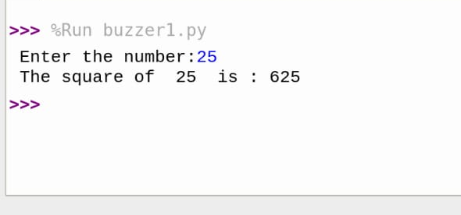

**Name: Atharva Velhankar  
Class: SE (A)  
Roll No: 22508  
Subject: IOTL**

**Lab Practical 9**

Problem Statement:

Write a program to control the color of the LED by turning 3 different potentiometers. One will be read for the value of Red, one for the value of Green, and one for the value of Blue.

//Code:

int red_light_pin= 5;

int green_light_pin = 6;

int blue_light_pin = 3;

unsigned int red,green,blue;

void setup() {

pinMode(red_light_pin, OUTPUT);

pinMode(green_light_pin, OUTPUT);

pinMode(blue_light_pin, OUTPUT);

}

void loop() {

red = analogRead(A0); // reads the value from the specified analog pin present on the particular Arduino board and returns a number between 0 and 1023 that is proportional to the amount of voltage being applied to the pin.

red = (red/4);

green = analogRead(A2);

green = (green/4);

blue = analogRead(A3);

blue = (blue/4);

RGB_color(255-red, 255-green, 255-blue); // turning potentiometer will show change in color

delay(1000);

/*RGB_color(0, 255, 255); // Red (show by removing comments without turning

delay(1000);

RGB_color(255, 0, 255); // Green

delay(1000);

RGB_color(255, 255, 0); // Blue

delay(1000);

RGB_color(0, 0, 125); // Raspberry

delay(1000);

RGB_color(255, 0, 0); // Cyan

delay(1000);

RGB_color(0, 255, 0); // Magenta

delay(1000);

RGB_color(0, 0, 255); // Yellow

delay(1000);

RGB_color(0, 0, 0); // White

delay(1000);

*/

}

void RGB_color(int red_light_value, int green_light_value, int blue_light_value)

{

analogWrite(red_light_pin, red_light_value);

analogWrite(green_light_pin, green_light_value);

analogWrite(blue_light_pin, blue_light_value);

}

OUTPUT:

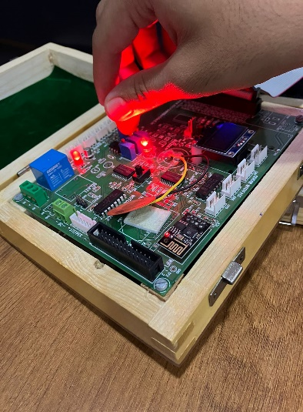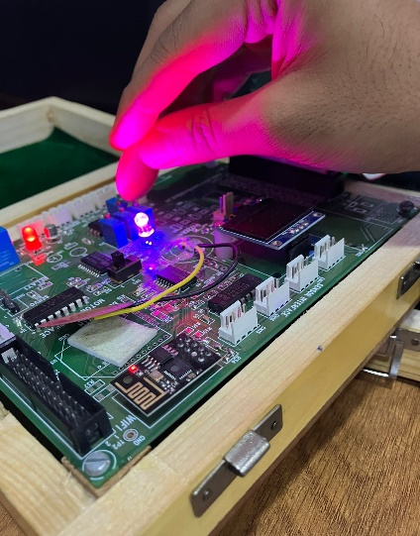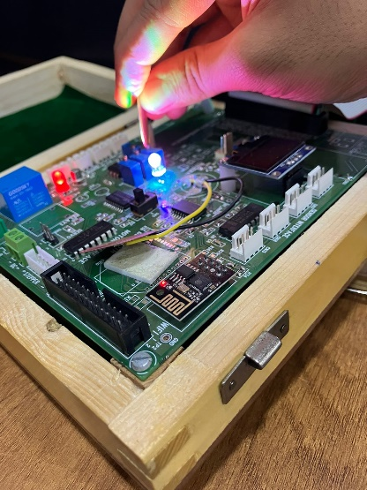

**Name: Atharva Velhankar  
Class: SE (A)**

**Roll No: 22508  
Subject: IOTL**

**Lab Practical 10**

Problem Statement:

Write a program read the temperature sensor and send the values to the serial monitor on the computer.

//Code:

#include <SimpleDHT.h>

int pinDHT11 = A1;

SimpleDHT11 dht11(pinDHT11);

void setup()

{

Serial.begin(115200);

}

void loop() {

// start working...

Serial.println("=================================");

Serial.println("Sample DHT11...");

// read without samples.

byte temperature = 0;

byte humidity = 0;

int err = SimpleDHTErrSuccess;

if ((err = dht11.read(&temperature, &humidity, NULL)) != SimpleDHTErrSuccess)

{

Serial.print("Read DHT11 failed, err=");

Serial.print(SimpleDHTErrCode(err));

Serial.print(",");

Serial.println(SimpleDHTErrDuration(err));

delay(1000);

return;

}

Serial.print("Sample OK: ");

Serial.print((int)temperature); Serial.print(" *C, ");

Serial.print((int)humidity); Serial.println(" H");

// DHT11 sampling rate is 1HZ.

delay(1500);

}

OUTPUT:

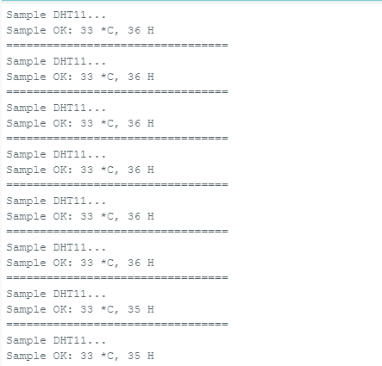

**Name: Atharva Velhankar  
Class: SE (A)**

**Roll No: 22508**

**Subject: IOTL**

**Lab Practical 11**

Problem Statement:

Write a program using piezo element and use it to play a tune after someone knocks.

//Code:

const int buzzer = A1; // LED connected to digital pin 13

const int knockSensor = A1; // the piezo is connected to analog pin 0

const int threshold = 400; // threshold value to decide when the detected sound is a knock or not

// these variables will change:

int sensorReading = 0; // variable to store the value read from the sensor pin

void setup() {

pinMode(buzzer,INPUT);

}

void loop() {

// read the sensor and store it in the variable sensorReading:

pinMode(buzzer,INPUT);

sensorReading = analogRead(knockSensor);

// if the sensor reading is greater than the threshold:

if (sensorReading >= threshold) {

pinMode(buzzer,OUTPUT);

tone(buzzer,261);

// Waits some time to turn off

delay(200);

//Turns the buzzer off

noTone(buzzer);

// Sounds the buzzer at the frequency relative to the note D in Hz

tone(buzzer,293);

delay(200);

noTone(buzzer);

// Sounds the buzzer at the frequency relative to the note E in Hz

tone(buzzer,329);

delay(200);

noTone(buzzer);

// Sounds the buzzer at the frequency relative to the note F in Hz

tone(buzzer,349);

delay(200);

noTone(buzzer);

// Sounds the buzzer at the frequency relative to the note G in Hz

tone(buzzer,392);

delay(200);

noTone(buzzer);

}

delay(100); // delay to avoid overloading the serial port buffer

}

OUTPUT:

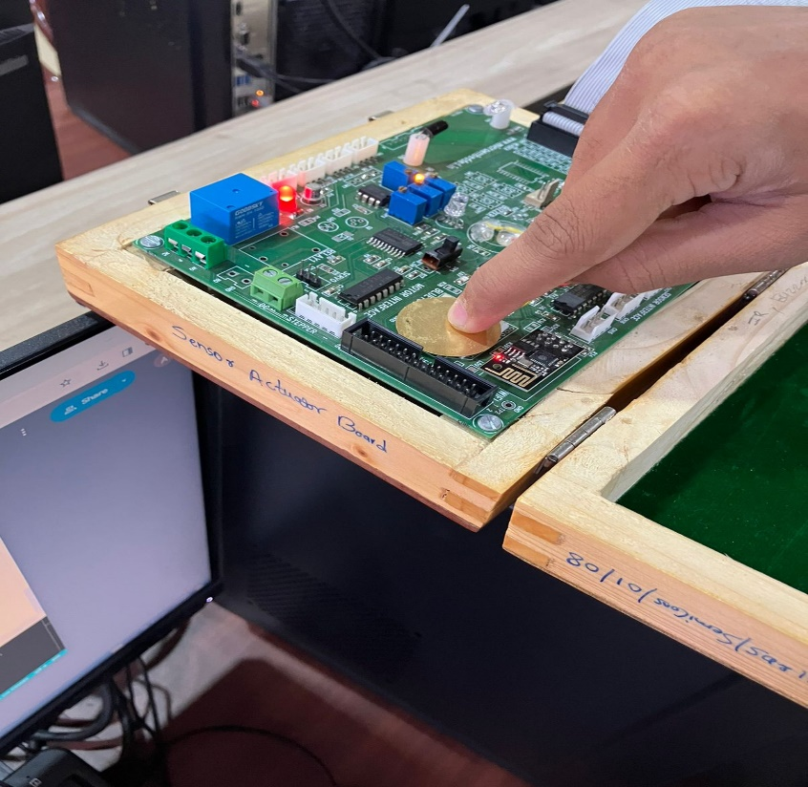

**Name: Atharva Velhankar  
Class: SE (A)  
Roll No: 22508  
Subject: IOTL**

**Lab Practical 12**

Problem Statement:

Understanding the connectivity of Raspberry-Pi /Beagle board circuit / Arduino with IR sensor. Write an application to detect obstacle and notify user using LEDs.

//Code:

void setup() {

// put your setup code here, to run once:

pinMode(4,OUTPUT);

pinMode(9,INPUT);

digitalWrite(4,HIGH);

}

void loop() {

if(digitalRead(9)== 1)

digitalWrite(4,HIGH);

else

digitalWrite(4,LOW);

}

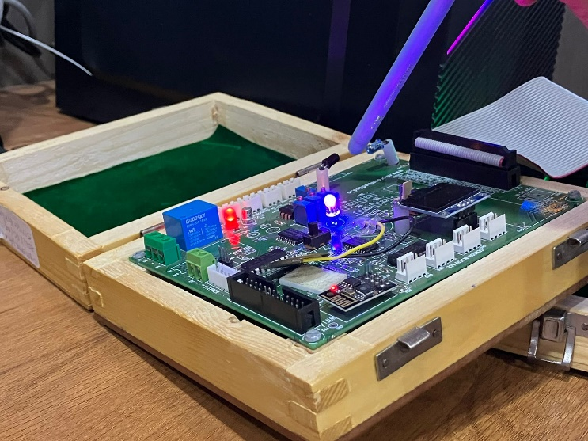OUTPUT:  
Before obstacle comes, After the obstacle comes

